Riphah International University
I-14 Campus Islamabad
Lab_Task_05
Department: Data Science
Subject: Data Structure
Submitted By:
Hammad Sajjad Awan
SAP ID:
76142
Submitted To:
Junaid Khan
Date Of Submission:
30-09-2026

Lab Report
Lab Activity 1:
Activity 1 — Types of Queue
Part A — Circular Queue
Implement a Circular Queue using an array.
The queue should have a fixed capacity of 5 elements.
Implement the following methods:
enqueue(int value)
dequeue()
peek()
display()
isEmpty()
isFull()
The program should:
- Insert elements using enqueue().
- Remove elements using dequeue().
- Display the front element using peek().
- Display all elements currently present.
- Detect Overflow when the queue is full.
- Detect Underflow when the queue is empty.
- Reuse the empty positions created after deletion.
Demonstration
Perform the following operations:
Enqueue 10
Enqueue 20
Enqueue 30
Enqueue 40
Dequeue
Dequeue
Enqueue 50
Enqueue 60
Display
Solution:
Circular Queue
enqueue(int value)
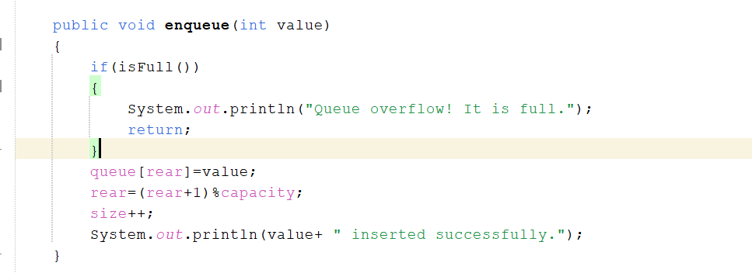

dequeue()
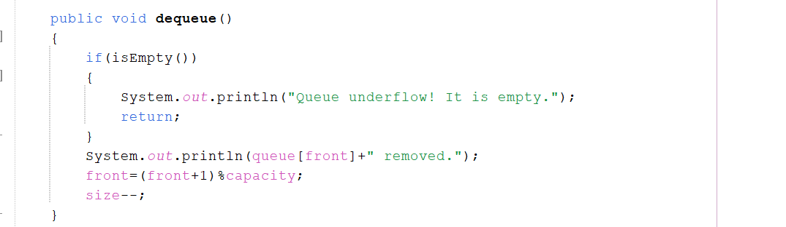
peek()
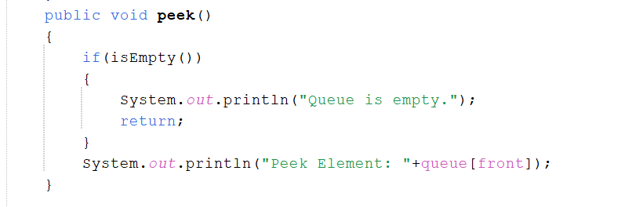
display()
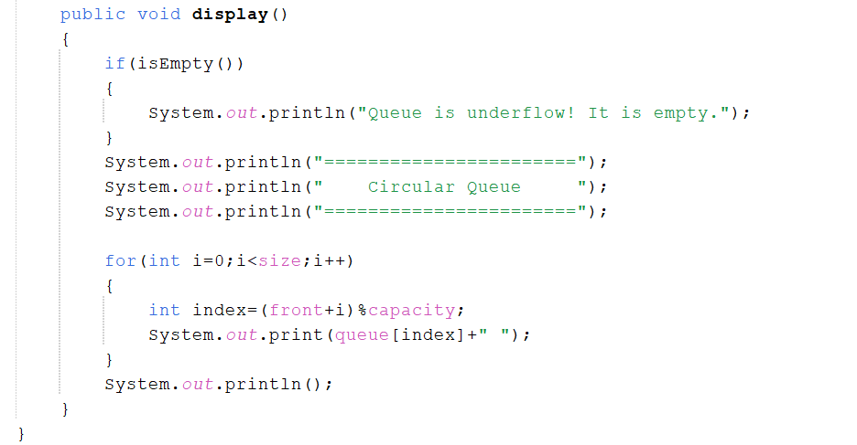
isEmpty()
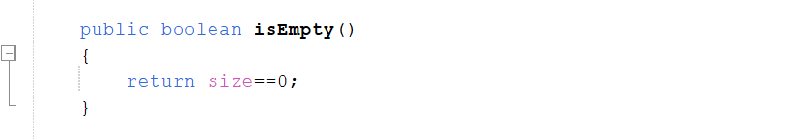
isFull()
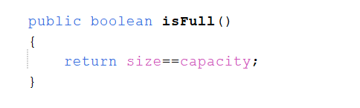
Complete Code:
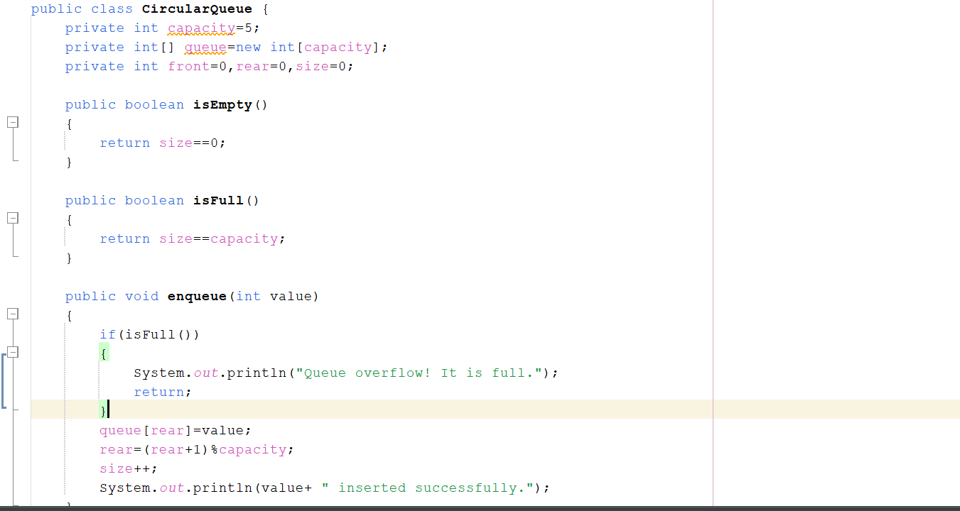
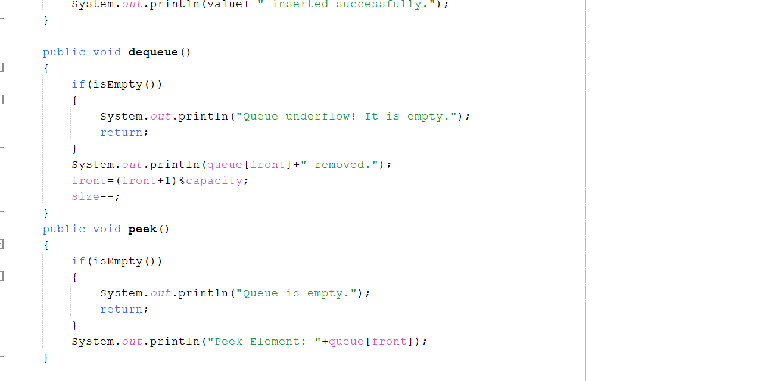
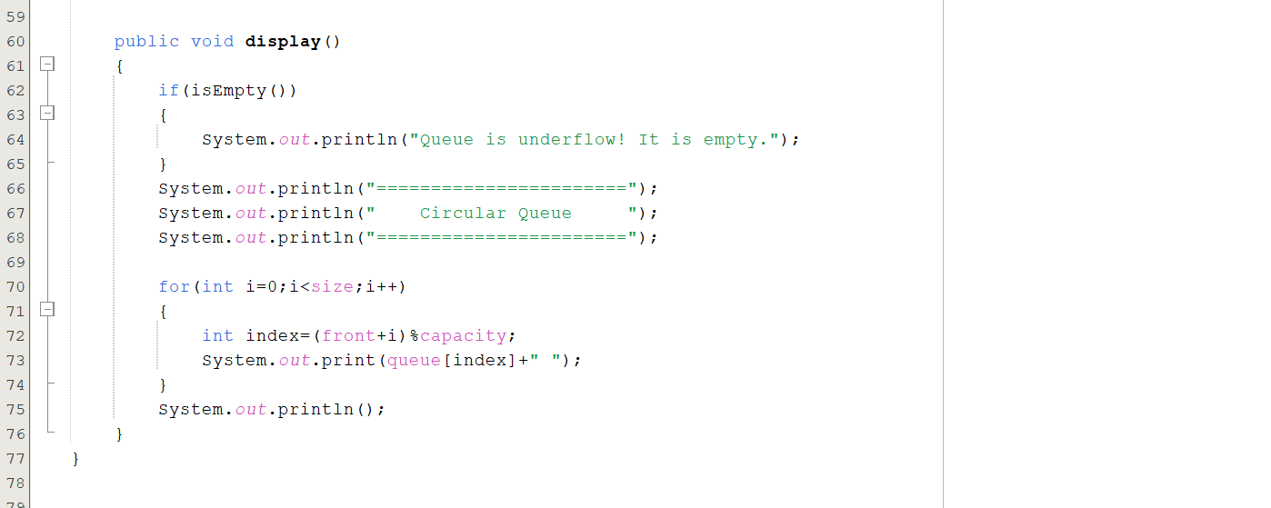
Output:
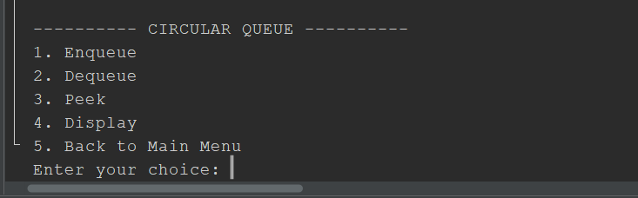
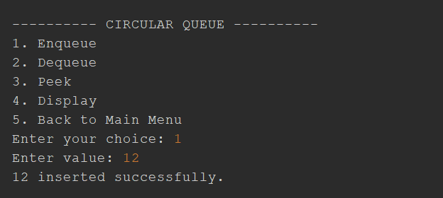
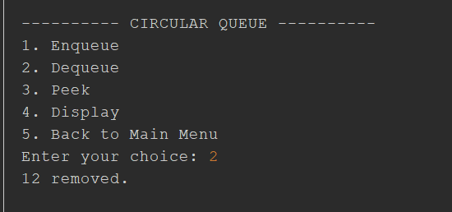
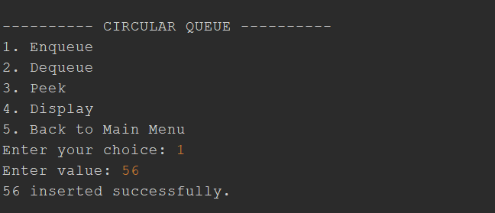

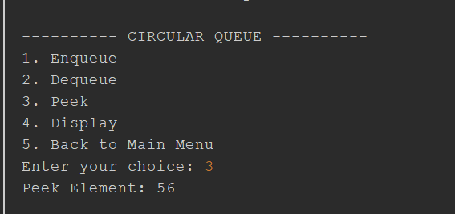
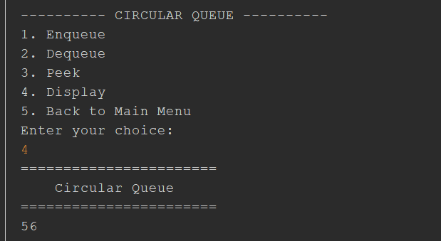
Question:
Part B — Priority Queue
Implement a simple Priority Queue using an array.
Each element should contain:
Value
Priority
Use the following example:
Value Priority
10 3
20 1
30 2
40 1
Implement operations to:
- Insert an element with its priority.
- Remove the element according to its priority.
- Display all elements currently present.
Observe how a Priority Queue differs from a normal FIFO Queue.
Answer:
Priority Queue
enqueue(int value)
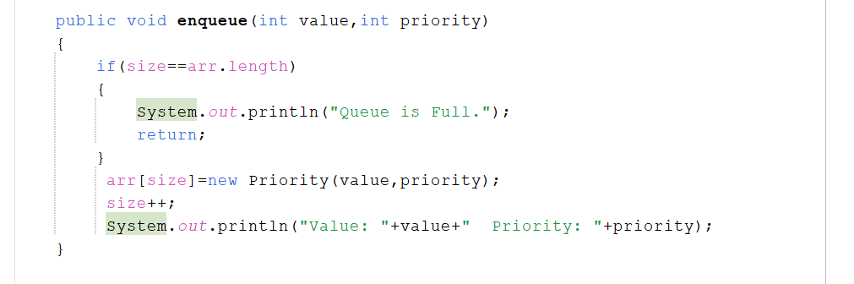
dequeue()
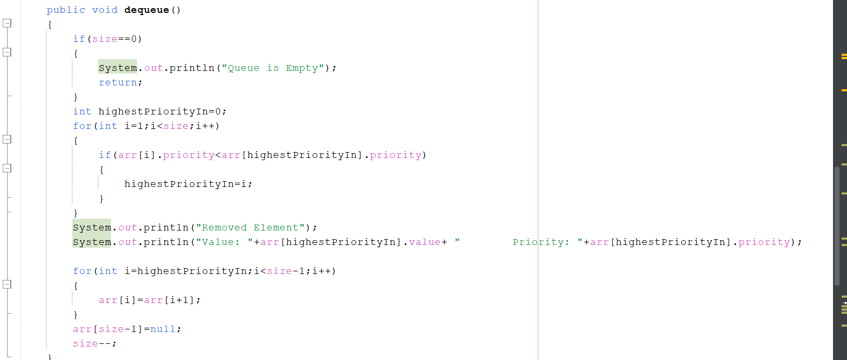
display()
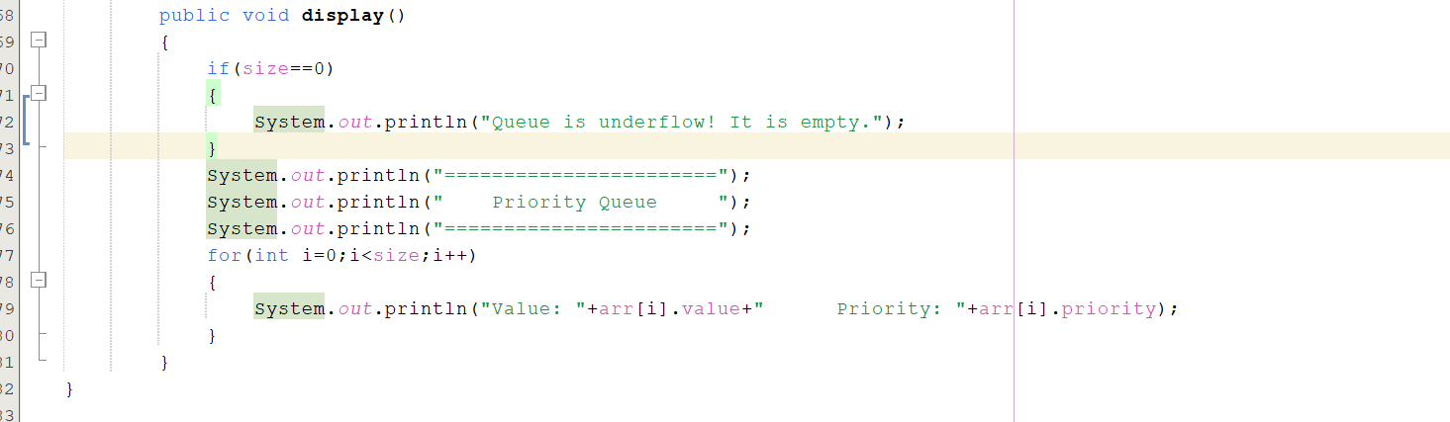

Complete Code:
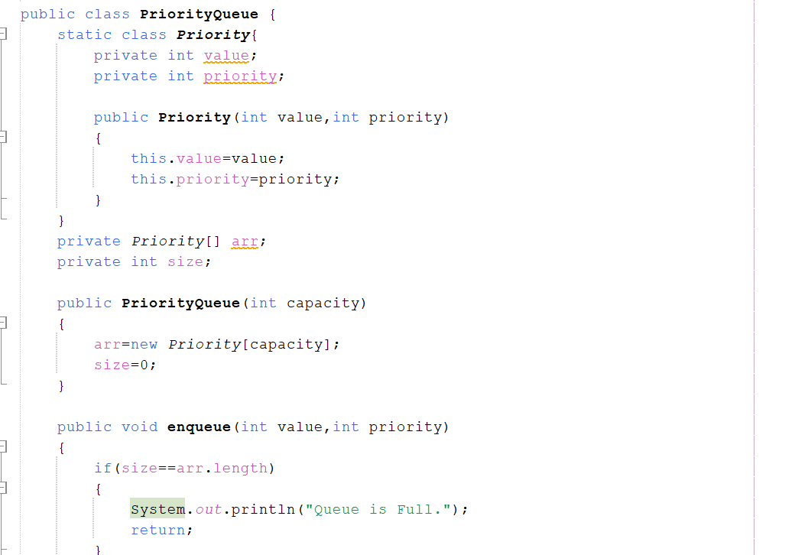
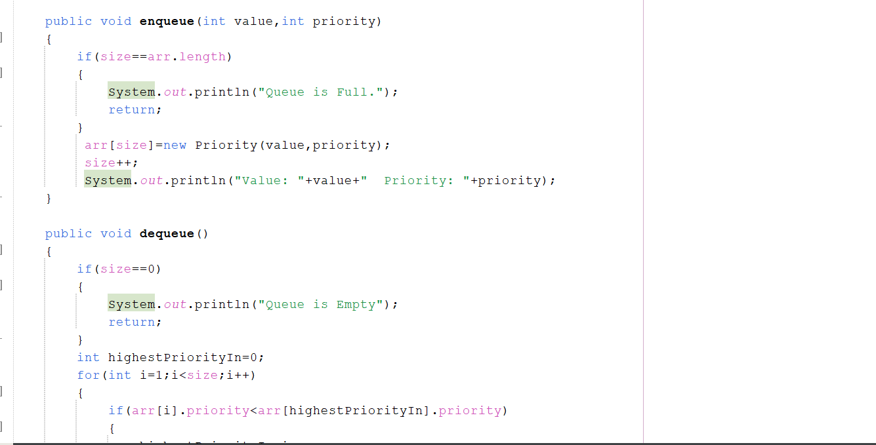
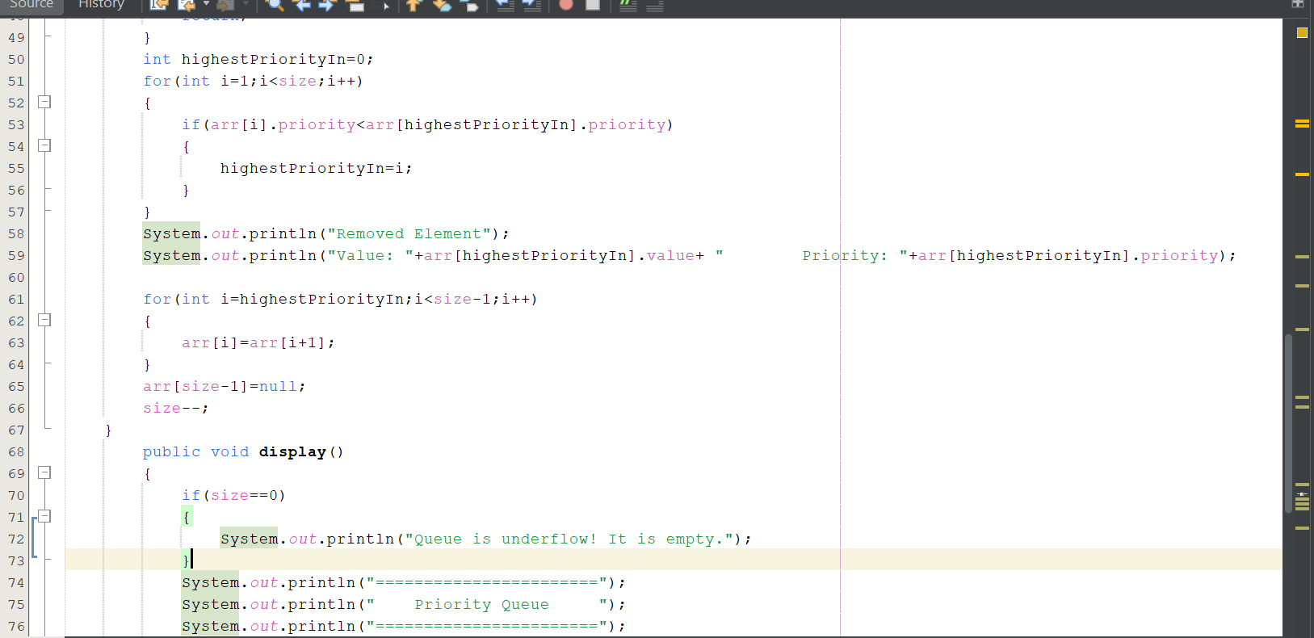
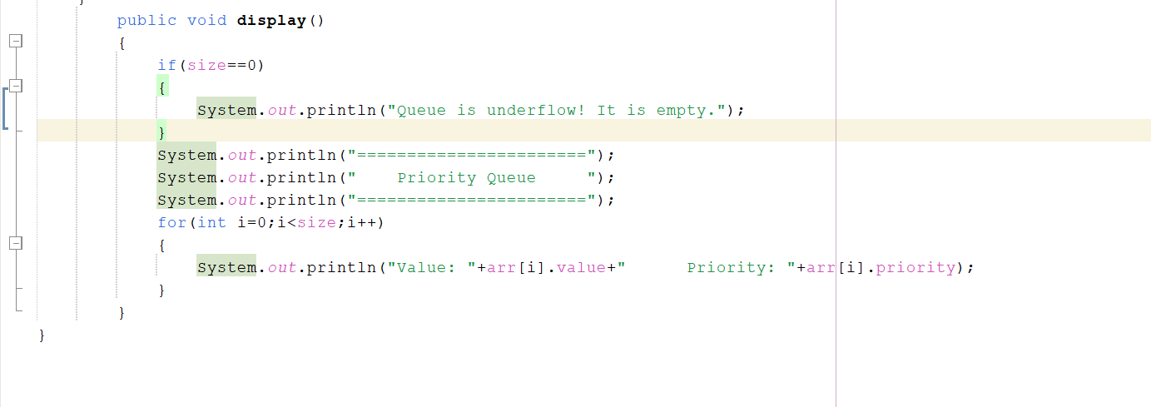
Output:
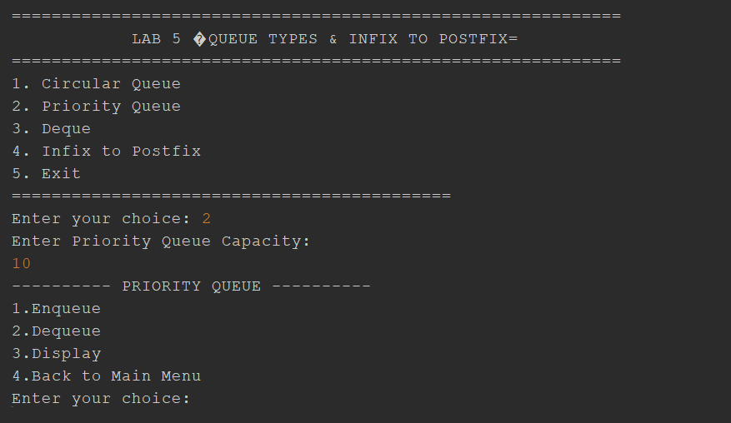
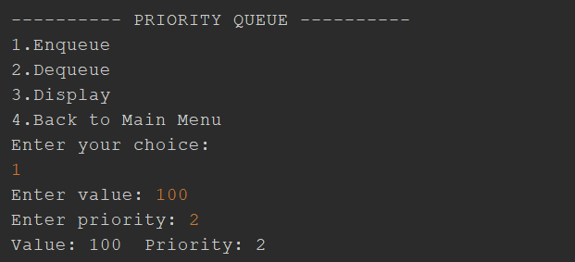
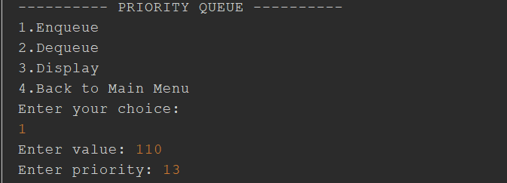
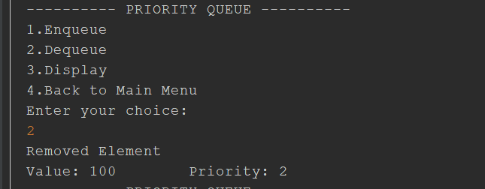
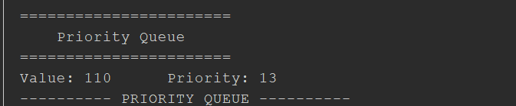
DEQUE
Question:
Part C — Deque
Implement a Deque (Double-Ended Queue) using an array.
A Deque allows insertion and deletion from both ends.
Implement the following operations:
insertFront()
insertRear()
deleteFront()
deleteRear()
display()
Demonstrate:
- Insertion from the front.
- Insertion from the rear.
- Deletion from the front.
- Deletion from the rear.
- Display of the current elements.

Answer:
insertFront()
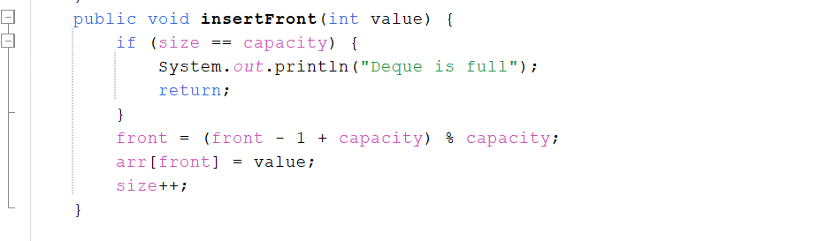

insertRear()
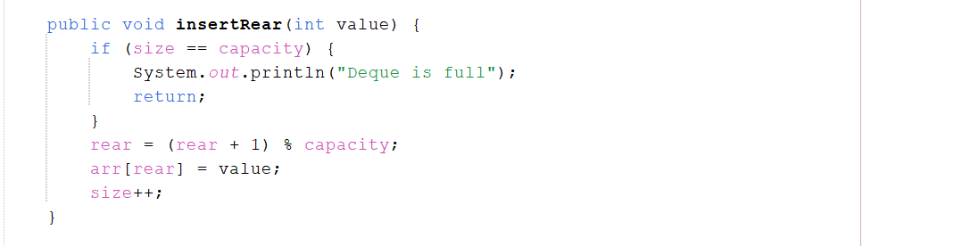
deleteFront()
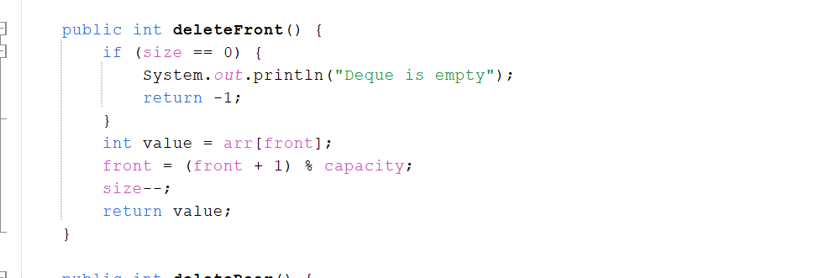
deleteRear()
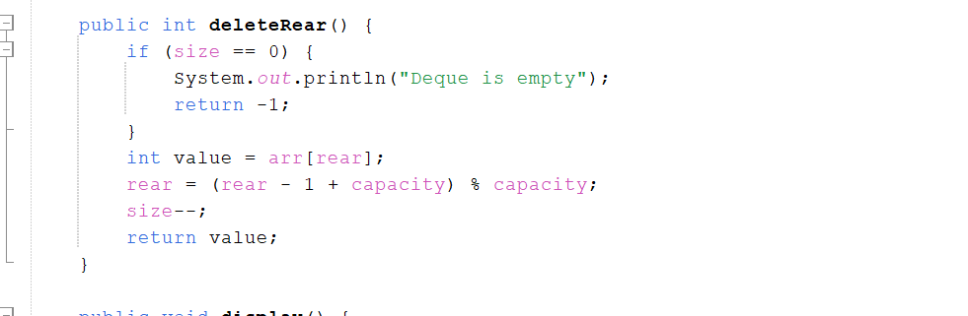
display()
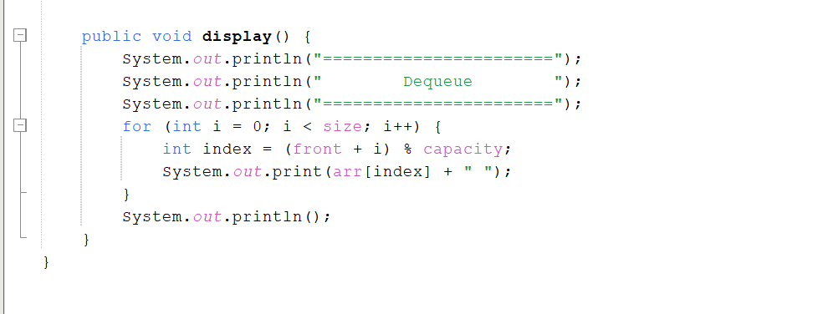
Complete Code:
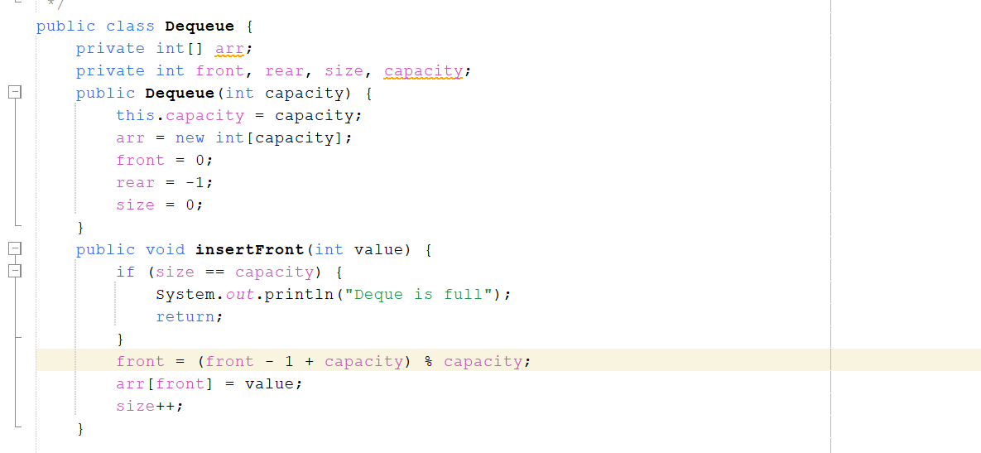
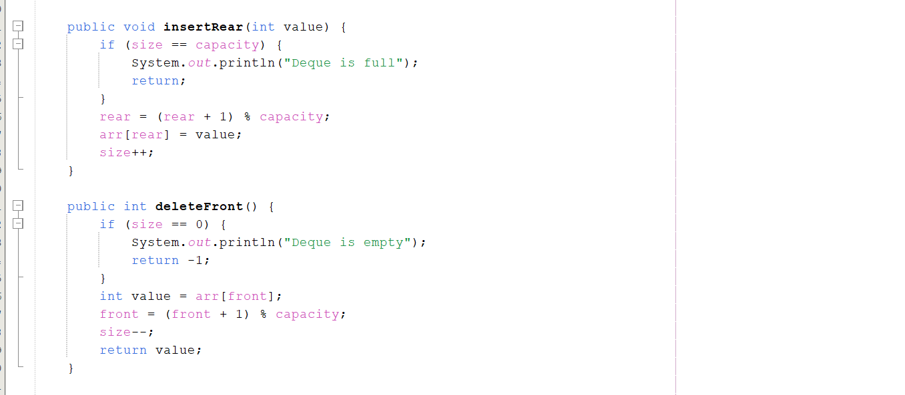
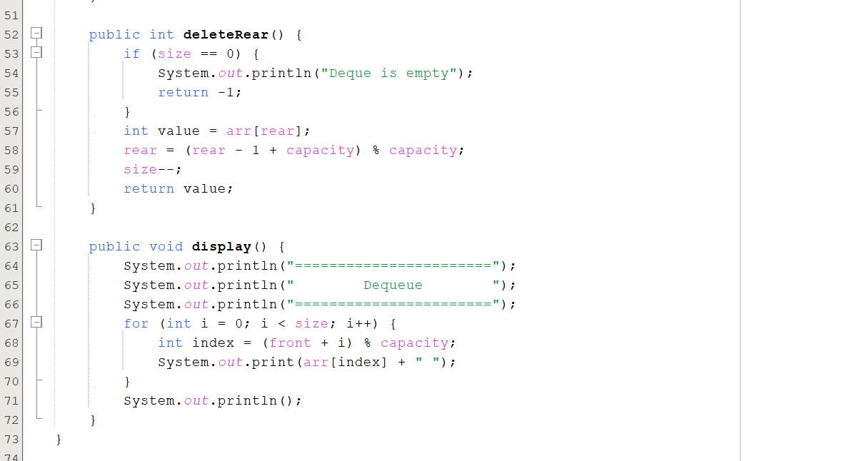
Output:
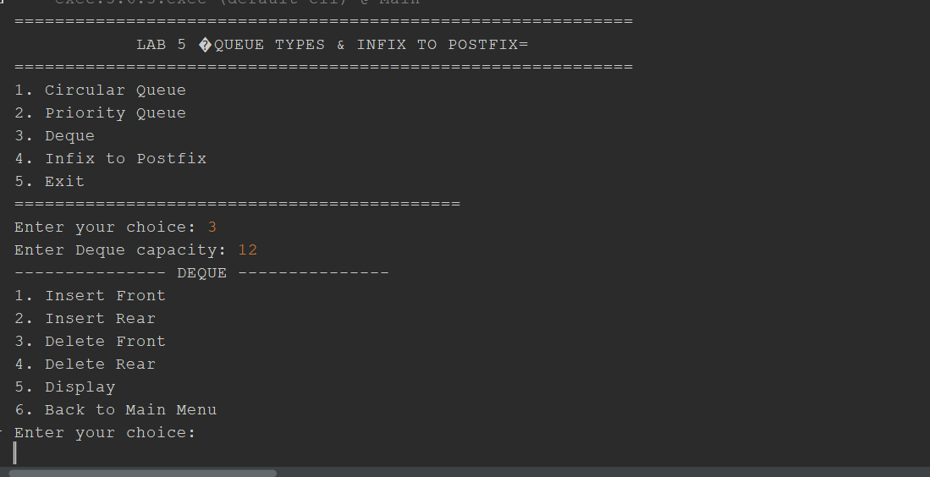
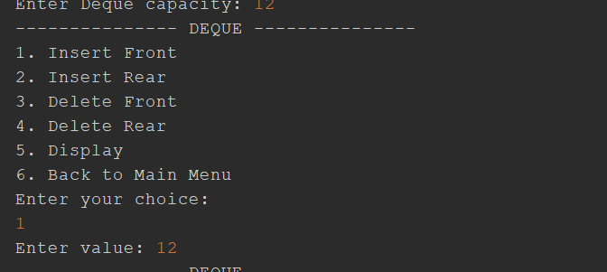
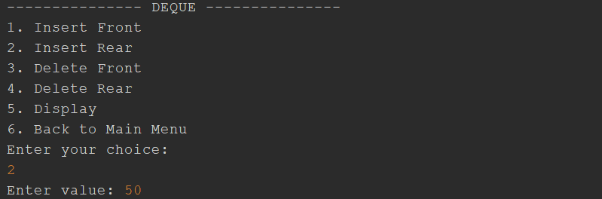
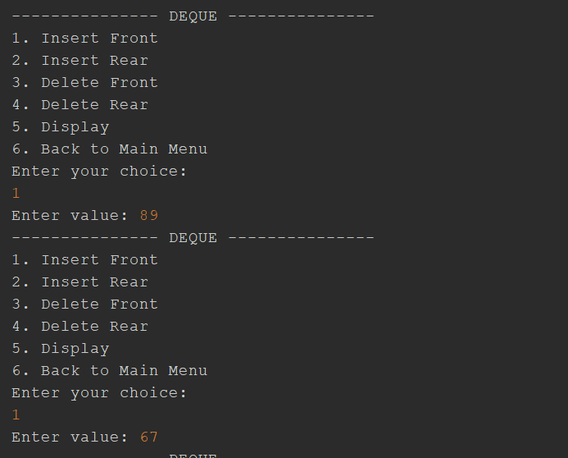
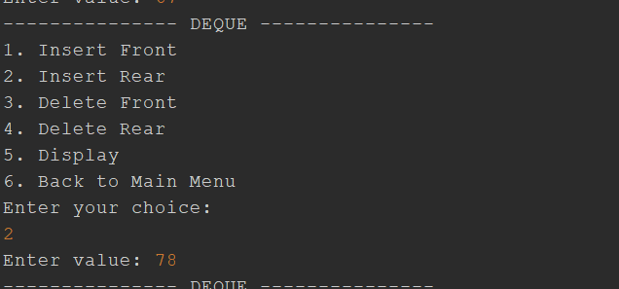
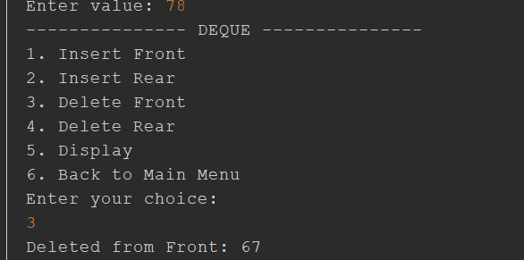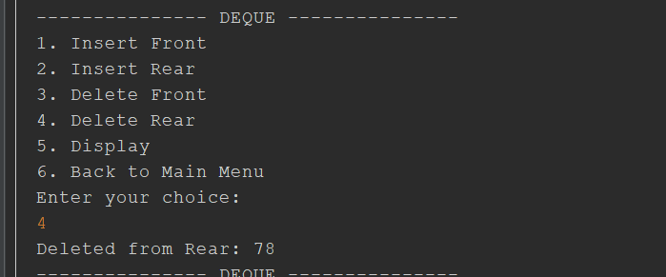
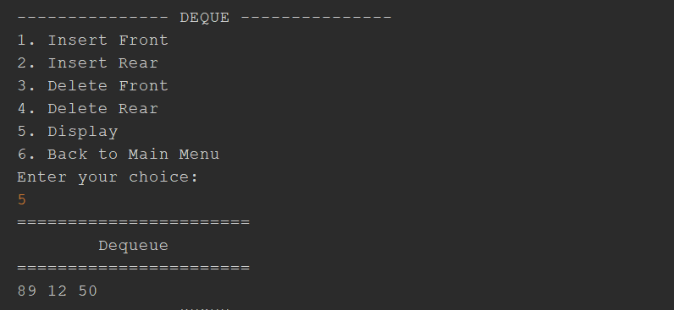

Lab Activity 2:
InfixPostFix
Task — Infix to Postfix
Create a Java program that converts an Infix expression into a Postfix expression using a Stack.
Implement a method:
infixToPostfix(String expression)
The program should:
- Read the expression from left to right.
- Add operands directly to the output.
- Push operators onto the Stack.
- Compare operator precedence when required.
- Handle opening and closing parentheses.
- Pop remaining operators from the Stack.
- Display the final Postfix expression.
Operators
Your program should initially support:
+ - * / %
Operator Precedence
Use the following precedence:
Operator | Precedence
*, /, % | Higher
+, - | Lower
Parentheses should have the highest priority during expression processing.
Answer:
Complete Code:
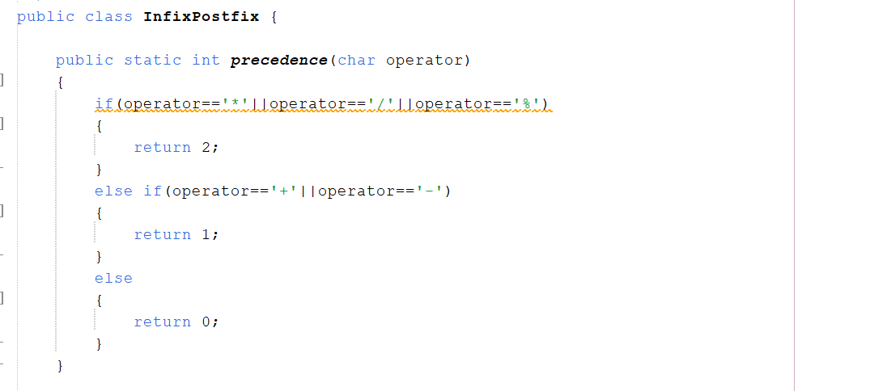

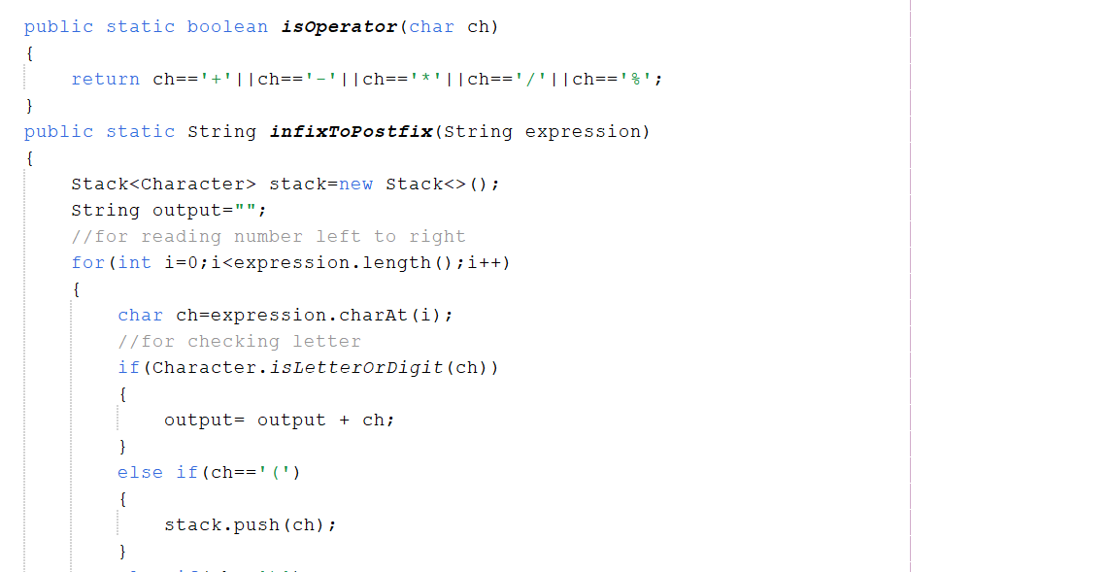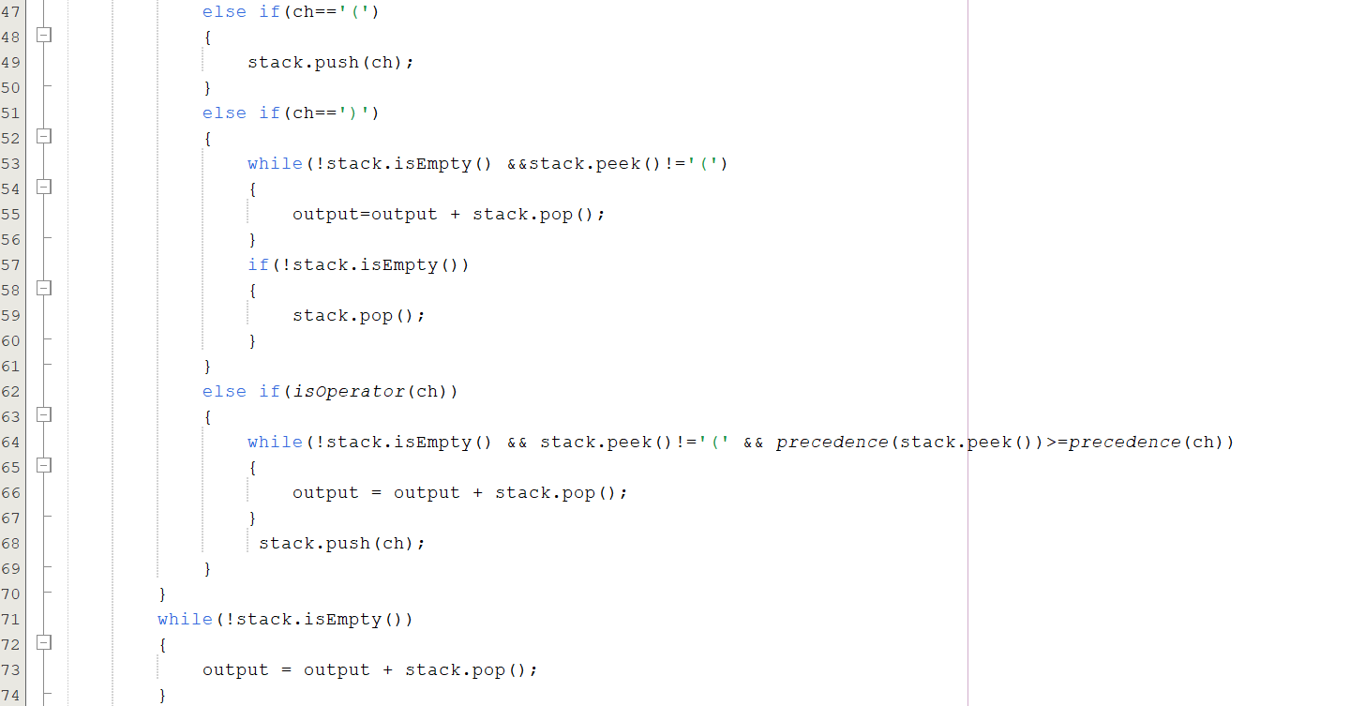
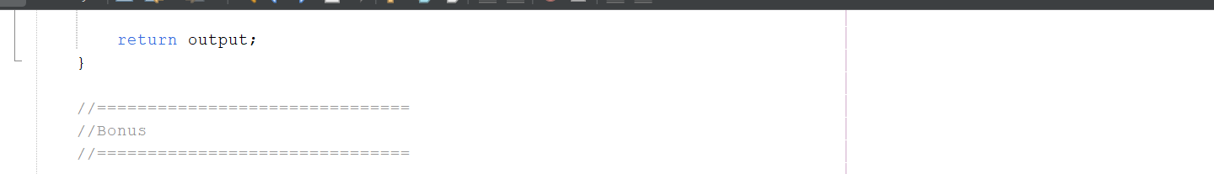
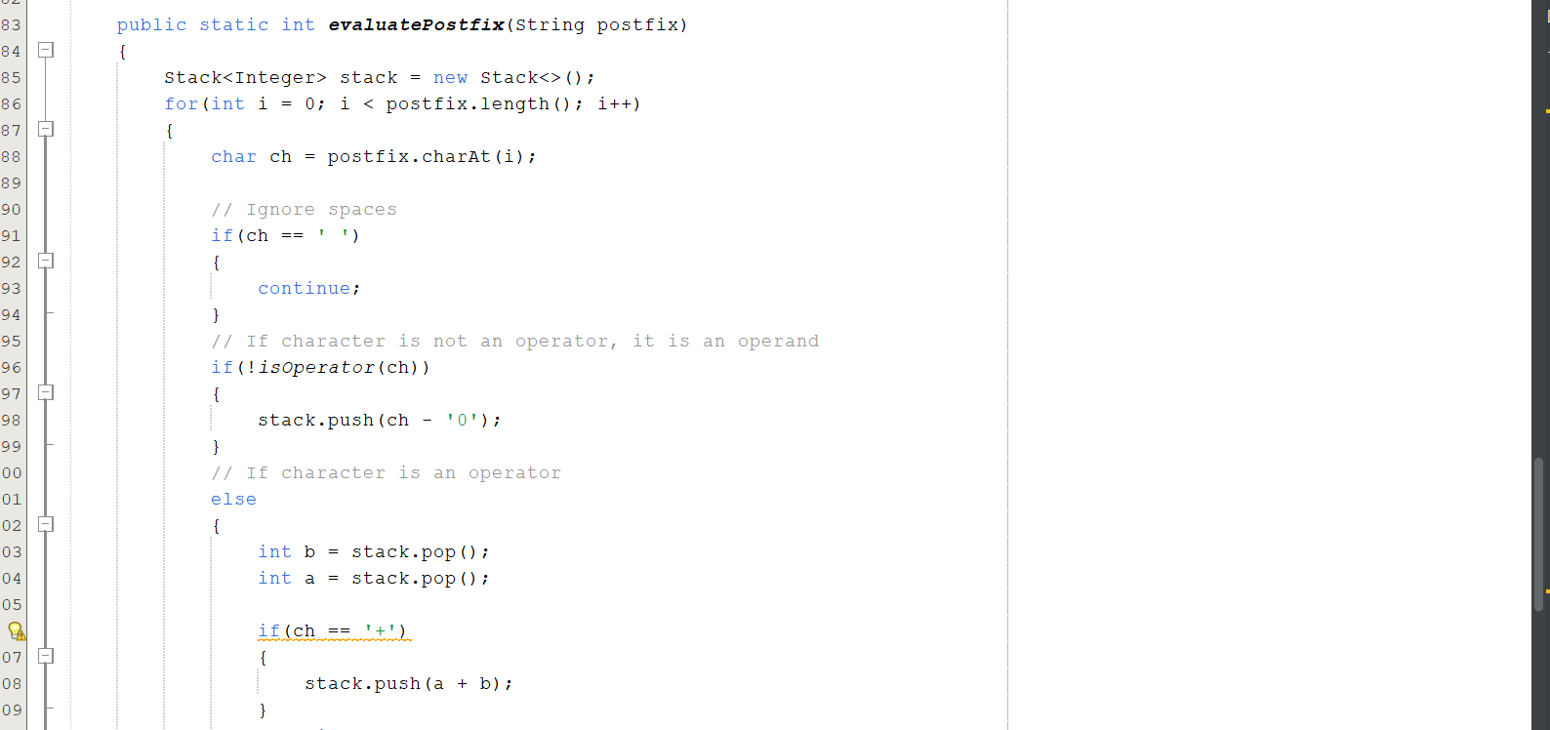
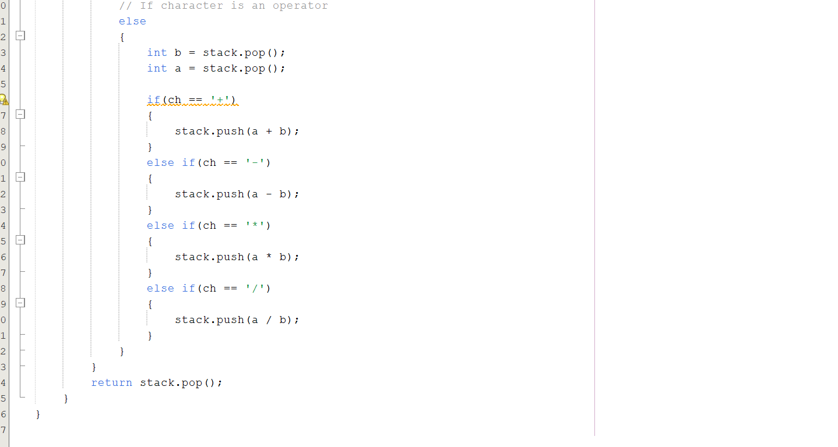
Output:
Example 1:
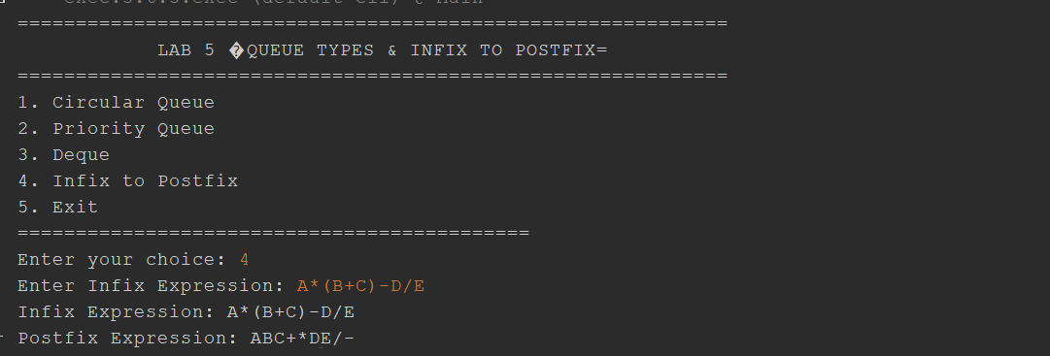
Example 2:
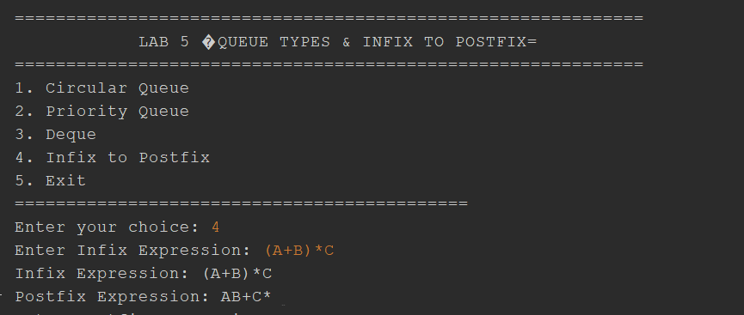
Example 3:
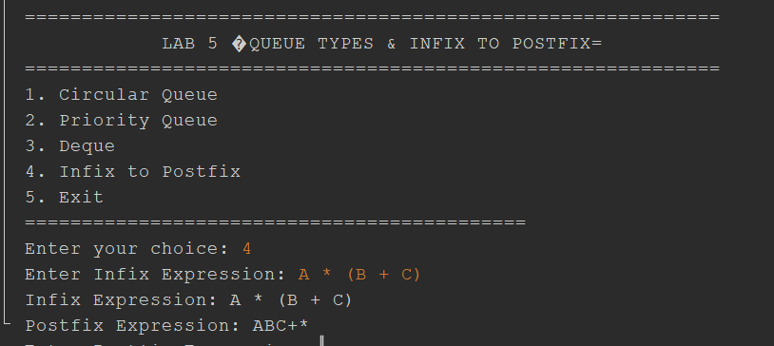
Lab Activity 3:
Activity 3 — Menu-Driven Queue and Expression Program
Develop a menu-driven Java program that demonstrates the concepts covered in this lab.
Menu
========== DATA STRUCTURES LAB 4 ==========

1. Circular Queue
2. Priority Queue
3. Deque
4. Infix to Postfix
5. Exit

Enter your choice:
The program should allow the user to select an operation and execute the corresponding functionality.
For the Infix to Postfix option, the program should:
- Ask the user to enter an Infix expression.
- Convert the expression into Postfix using a Stack.
- Display both the original and converted expressions.
Complete code of Main class:

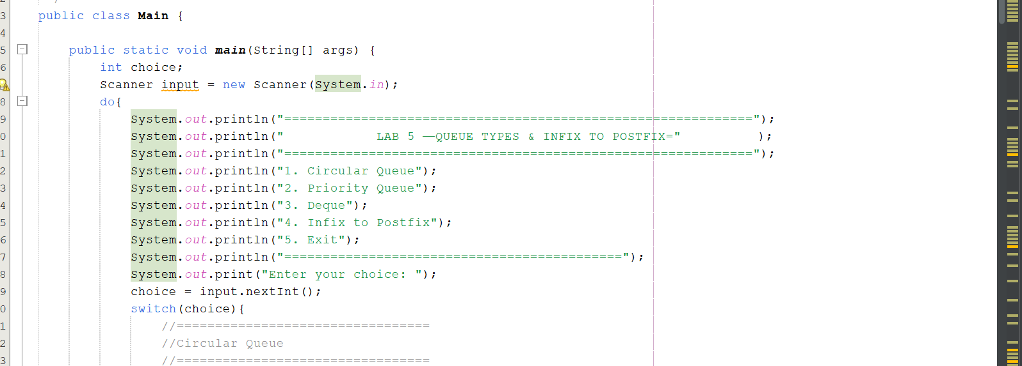
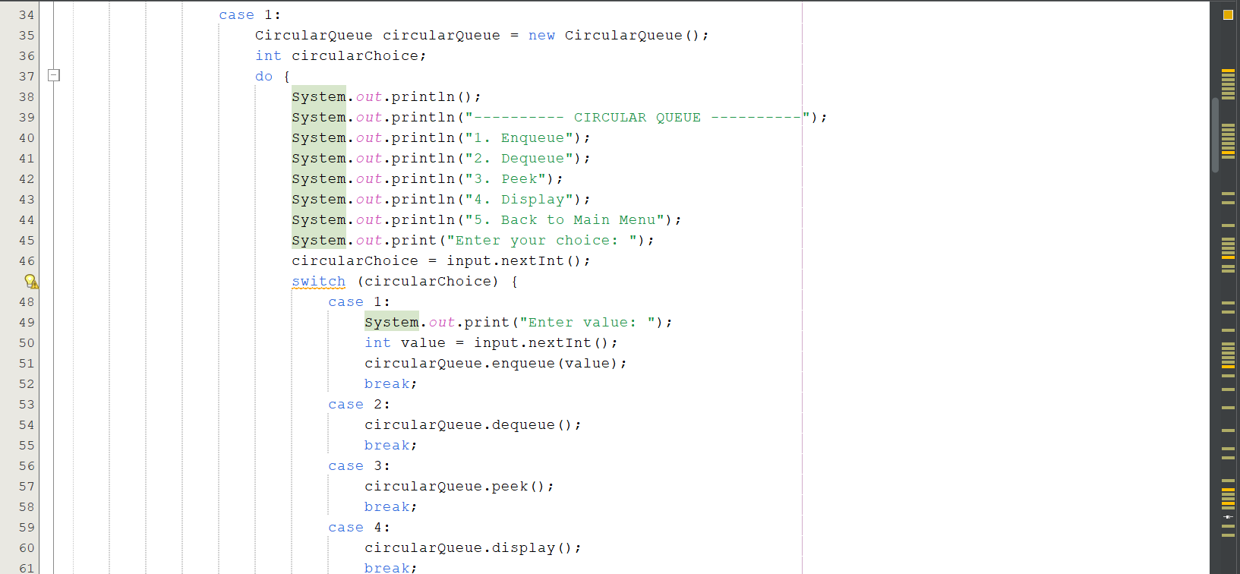
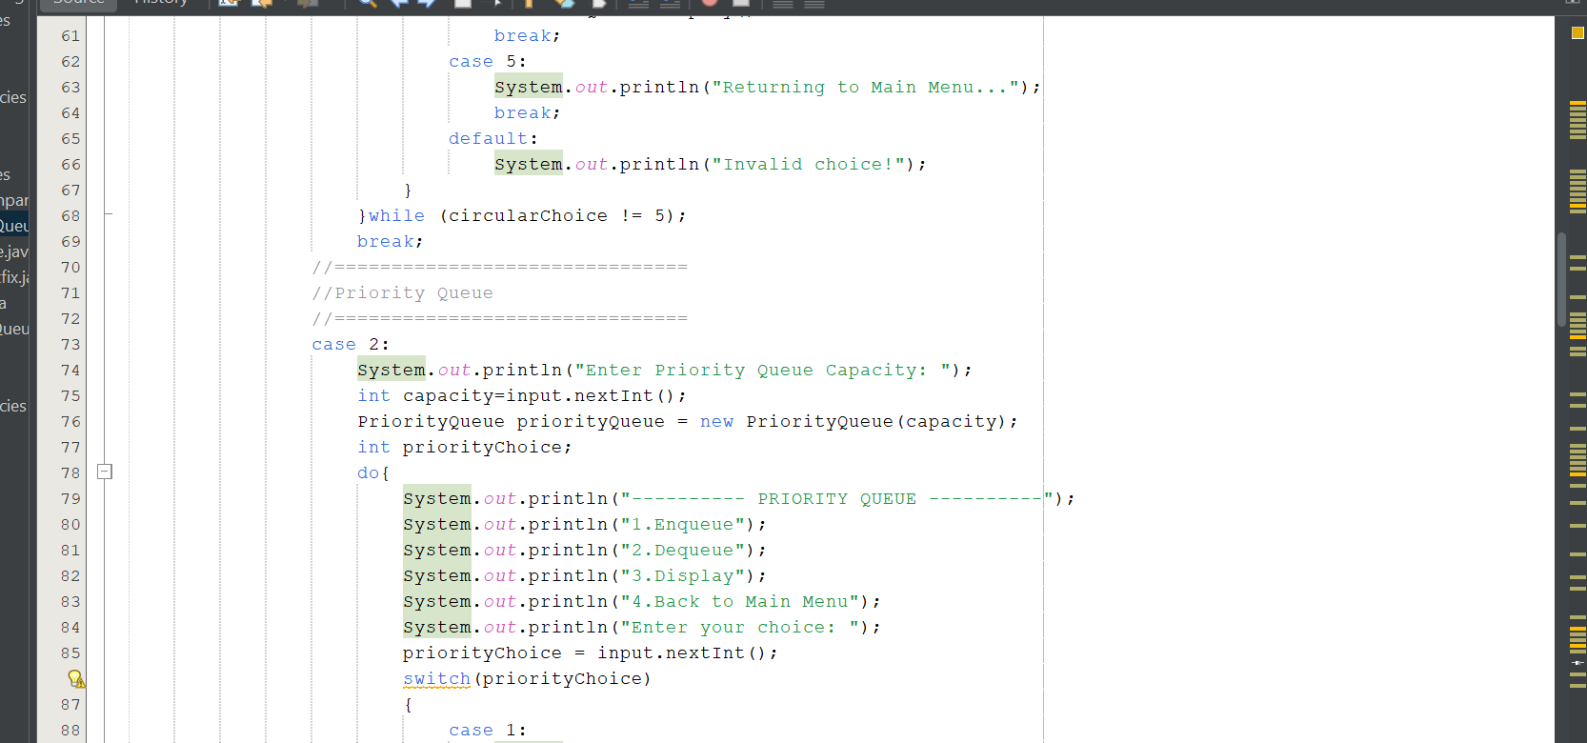
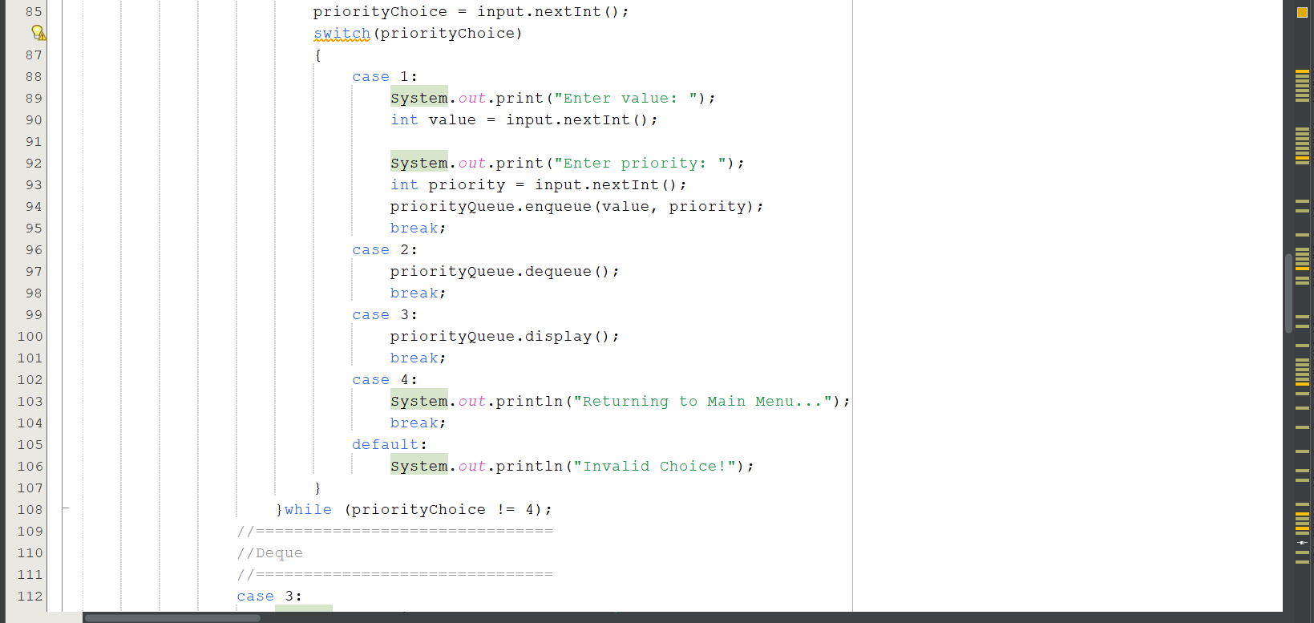
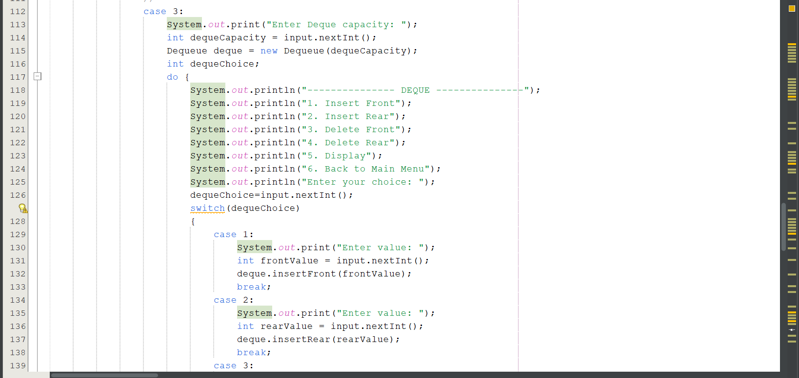
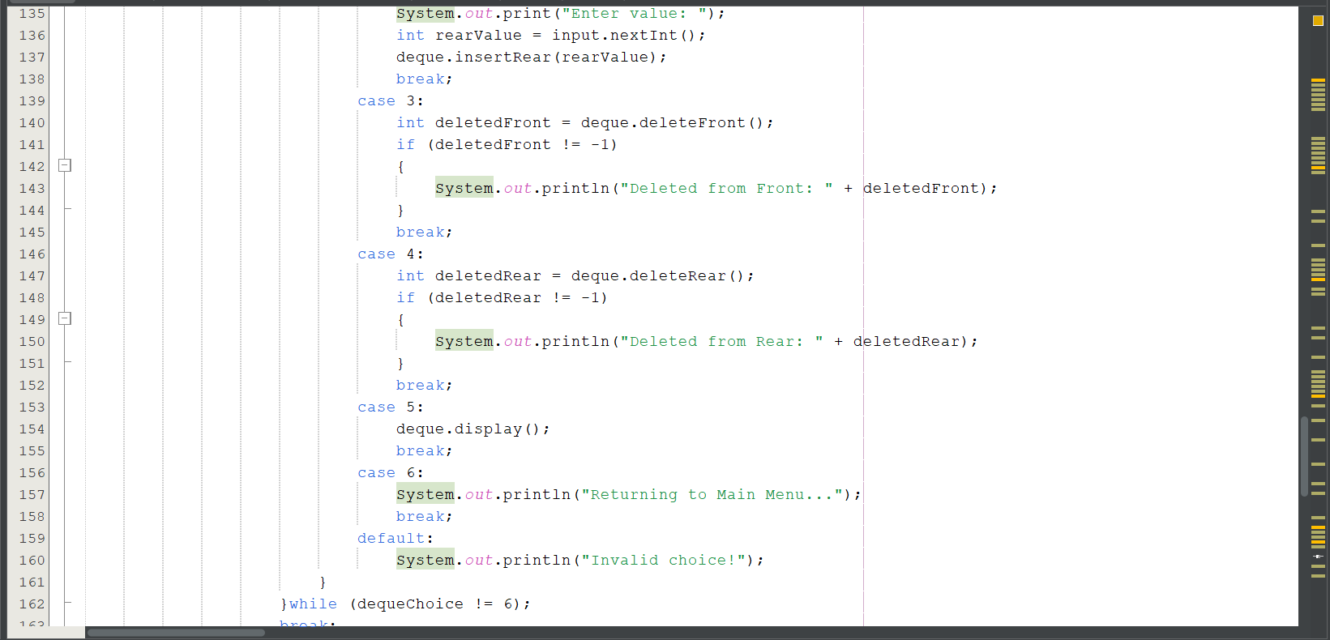
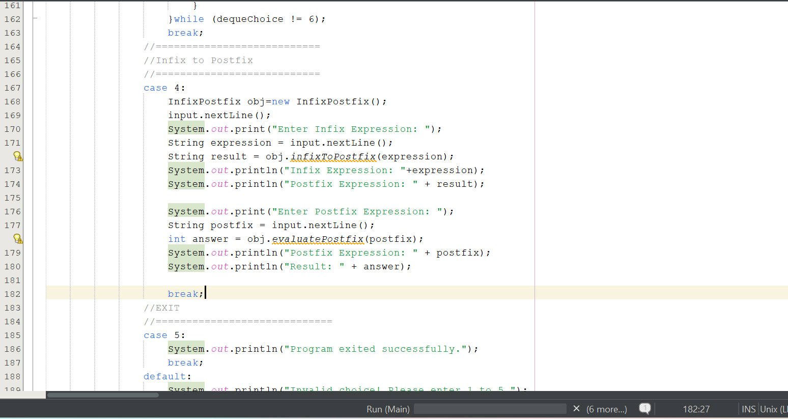
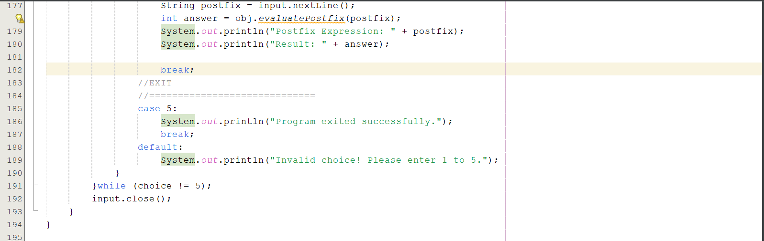
Output:
Menu-Driven Queue and Expression Program

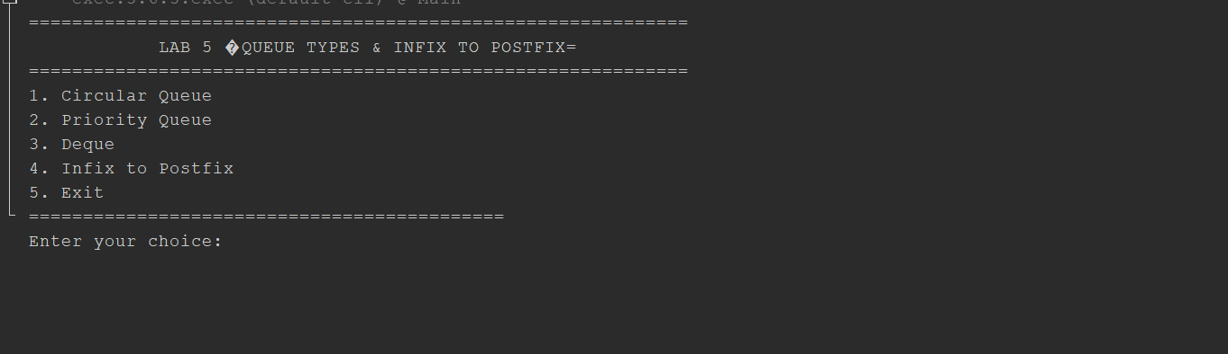
Bonus Task
Question:
4. Bonus Task — Postfix Evaluation
Extend the Infix-to-Postfix program to evaluate a Postfix expression using a Stack.
For example:
Postfix:
5 3 2 * +

Result:
11
The program should support:
+
-
*
/
This task is optional and may be attempted after completing the required activities.
Answer:
Complete Code:
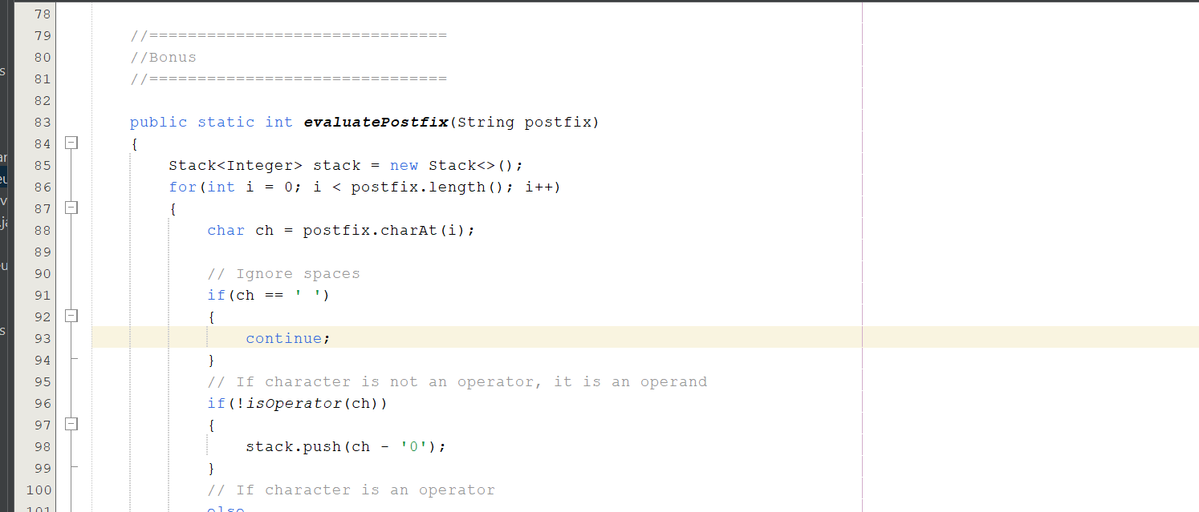
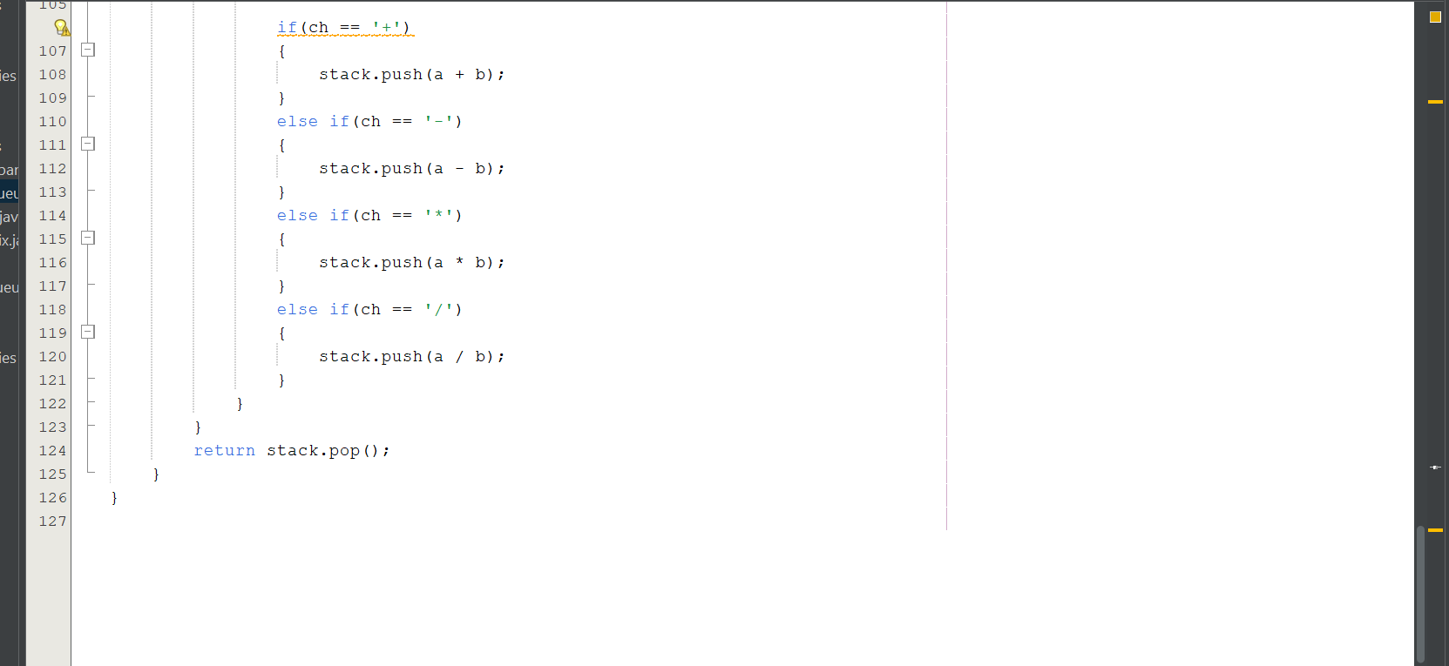
Output:
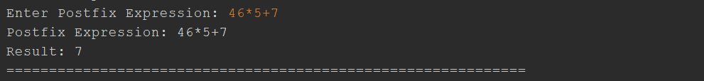
END

